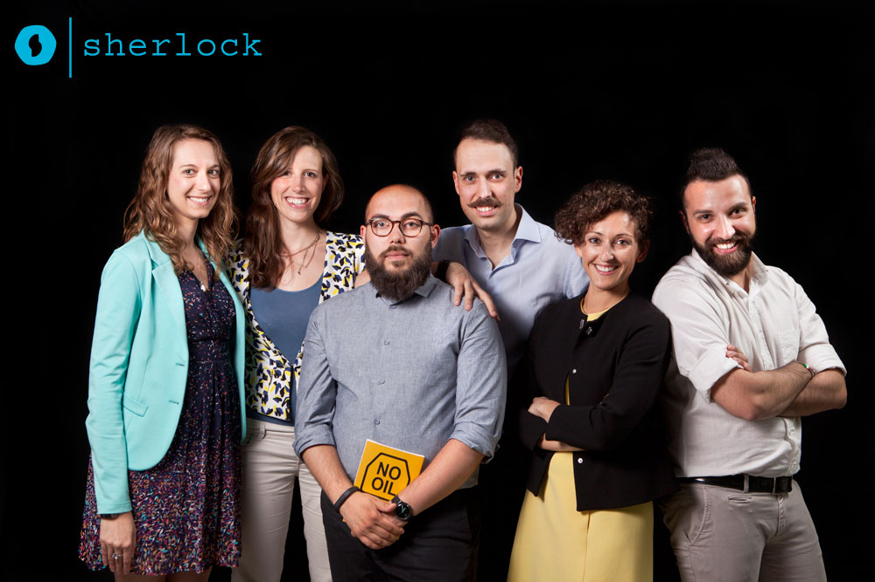

PIERLUIGI FRENI – CEO
Pierluigi is a Materials Engineer and PhD fellow at Politecnico di Torino. As a student, he spent 6 months in Stockholm for an Erasmus exchange programme at KTH. He also attended the Alta Scuola Politecnica. He has experience in ecodesign, material selection and environmental assessment. He carried on the entrepreneurial project EAPtics with Matteo Stoppa in the biomedical field.

MATTEO STOPPA – CTO
Matteo is a Biomedical Engineer and holds a PhD in Electronic. Previously, he was an intern in R&D Unit in Thales Alenia Space of Turin in biomedical space-crew support technologies. He was in charge of designing the electronic circuits in the EAPtics entrepreneurial project carried on together with Pierluigi Freni.

NATHALIE BIOLCATI RINALDI – CFO
After a degree in Foreign Trade at University of Turin and a double degree program in International Management at University of Lyon, she was an intern in logistics and banking in Unicredit group. She joined Fiat Chrysler Automobiles in 2010 as Energy Taxation Client Manager, specialized in custom law, excise and environmental taxation.

STEFANO MARTINALLO – Software Engineering
Stefano worked on the System and Debugging team at Intel and he got a Master Degree in Computer Engineering after developing his thesis at Chalmers University, in Gothenburg. He takes care of the back end, working with C, C++, Java, Python, Ruby, Arduino or even Assembly, among different OSs such as Linux, OSX and Windows.

MARZIA TESTA – Marketing & Communication
Having completed her Bachelor Degree in Foreign Languages with a specialization in English and German, Marzia graduated at the University of Milano Bicocca with a Masters Degree combining Psychology and Information Technology. She now works as a User Experience Designer in a consulting firm, where she focuses on usability of mobile and web interfaces.

FRANCESCA MANNA – Business Development
Francesca got a degree in Foreign Trade at University of Turin, during which she spent six months as Erasmus student at the University of Oviedo. Then she obtained a double Master Degree in International Management at University of Lyon. She now works as a communication expert at Fiat Chrysler Automobiles while attending a Master in Business Administration.

