Sherlock is a GPS-based anti-theft device connected to a mobile app that allows cyclists to precisely locate their bicycle at every moment.
The Product
Sherlock is a compact electronic device that can be installed into the frame of the bicycle, making it invisible from the outside. It features a GPS module for position tracking and it is connected to the Internet. In the event of theft, the device sends a real time notification to the cyclist through the Sherlock mobile app.
In particular, the value that Sherlock offers is based on the following features:
- Bicycle localization: constant and precise monitoring of the bicycle position thanks to the combination of a GPS module and an Internet connection (GSM/GPRS). The position is defined with an error lower than 5 meters and it can be consulted through a smartphone app.
- Unobtrusive design: the device is very compact and light. It can be easily installed inside the handlebars and it is not visible from the outside. This way it is hard for the theft to detect it and the design of the bicycle is not altered.
- Unique ID: the system provides a univocal association user-device-bicycle, thanks to a “bicycle passport” that can be used to prove the ownership of the bicycle and to get the support of the police in the event of theft.
- Trouble free: the customer receives a turnkey solution, including a device that is easy to install, an Internet data plan and the localization service on a dedicated mobile app.
Bicycle theft
Every year more than 3 million bicycles are stolen in Europe and bicycle theft is a critical issue worldwide. Bicycle theft causes serious inconvenience for citizens and commuters who suddenly find themselves without their means of transportation. The fear of theft is a deterrent that limits a wider adoption of bicycles in cities and the victims of theft are more likely to spend less on the replacement bicycle, choosing something cheaper, less secure, and sometimes even turning to the black market.
Sherlock story
The idea of Sherlock came after experiencing bicycle theft ourselves. We had no means to retrieve what was stolen from us, and we felt helpless. The team was created around the original idea in Spring 2014, during an Entrepreneurship Programme held by Fondazione CRT-Cassa di Risparmio Torino in Turin (Italy). We were awarded a scholarship to join the SETsquared Entrepreneurship Programme in Bath (September 2014). The team is composed of seven members with strong diverse backgrounds: engineering (2 PhD), industrial design, international management, economics (1 MBA fellow) and UX design.
The project gained momentum in 2015, when the Sherlock Company was established and the project was awarded a €130.000 European grant (frontierCities) to support the development and the first marketing activities. Sherlock is now incubated at I3P (Incubatore di Imprese Innovative del Politecnico di Torino) and at SETsquared (Basingstoke, UK).

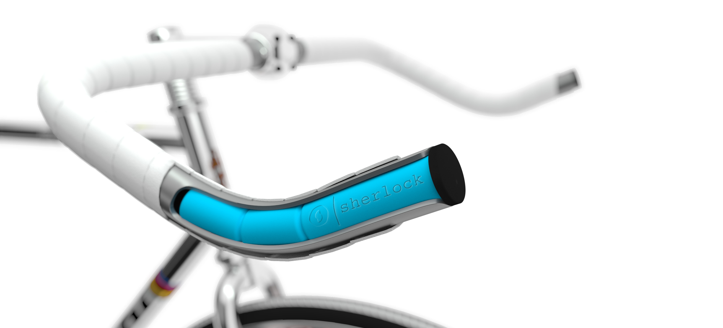

Contacts
Silvia Peretto | +39 333 8272592
| +44 748 1517758
Daniela Petrone | +39 347 3604457
press@sherlock.bike | www.sherlock.bike

